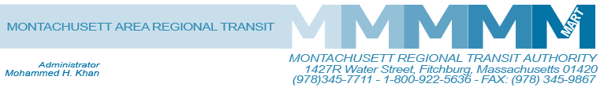

Posted 04/14/2016 at 1:51 pm by JAV

MEETING OF THE MART ADVISORY BOARD
MART Maintenance Facility
1427R Water Street
Fitchburg, MA 01420

Tuesday, April 19, 2016
10:30 A.M.

Agenda

- Call to Order
- General Comments
- Approval of Minutes
A. January 26, 2016
- Financial Matters
- Status of State Funding
- Status of Federal Funding
- Finance Committee Report
D. Financial Update
- Fiscal Year 2016: Status of Audit FY2016
- Budget and Income/Expenditures Report 8 months FY2016
E. Reforecast FY2016 Budget for the Advisory Board and Projected Revised Local Assessments

V. Administrative Matters
- Implementation of Cost of Living Increase for Staff effective January 1, 2016
RESOLUTION-BE IT RESOLVED that the Advisory Board of the Montachusett Regional Transit Authority approves a cost of living increase of 2.5% for all MART staff effective January 1, 2016 as recommended by the Administrator.
- Review of Retirement Proposal
RESOLUTION-BE IT RESOLVED that the Advisory Board of the Montachusett Regional Transit Authority approves the non-defined benefit pension plan (10% employer contribution) as presented.
C. The Northeast (Massachusetts) Homeland Security Regional Advisory Council (NERAC) has asked MART to host an AmbuBus for transporting non-mobile patients during large emergencies evacuations. MART is asking the Board to approve hosting this bus.
D. COA Transportation Contract and Insurance Transfer to Towns for COA Vehicles
VI. Operational Services
A. MART Operation Status on Revenue and Ridership 8 Month Review
VII. Other Business
A. The Proposed Commuter Rail Schedule and Improvement

VIII. Adjournment
C: City and Town Clerks: Please post this notice pursuant to MA General Laws Chapter 30A,
Section 11 ½.

